**AIM**

To write and execute a Prolog program that stores and retrieves the names and dates of birth of persons.

**ALGORITHM**

1. **Start** the program.
2. Define facts in the form person(Name, DOB). where:
   * Name is the person’s name.
   * DOB is the person’s date of birth.
3. Load the program into the Prolog interpreter.
4. Query the database using variables, e.g., ?- person(Name, DOB).
5. Prolog will return all stored names and their corresponding dates of birth.
6. **Stop**.

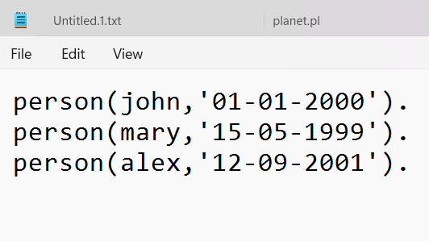

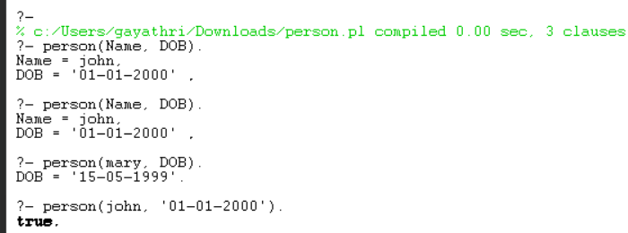

**Result:**

 The program successfully stores and retrieves the names and dates of birth of persons from the knowledge base.